1-Page Summary Report

Problem Statement
Estimate the linear relationship between capital allocated to Mintos loan investments and interest earned (passive income), and (as secondary practice) the link between the number of originators in a portfolio and realized net return %. The educational goal is to implement simple linear regression both from scratch via gradient descent and with scikit-learn / closed-form OLS, framed around two of the top reasons people use Mintos: competitive passive returns and diversification across originators.

Solution Strategy
1. Explore the capital–interest scatter. 2. Define SSE loss and derive analytic gradients. 3. Implement iterative gradient descent with a centering trick (essential when capital is in thousands of euros). 4. Verify against the normal equations and sklearn. 5. Diagnose residuals and run Monte-Carlo simulations. 6. Estimate a diversification model (realized return % on number of originators). Audience-aware language is prepared for quantitative investors, retail/passive investors, diversification-focused users and non-specialists.

Solution
Key numerical results (capital → interest): slope (effective yield) ≈ 0.109 (€ interest per € capital, ~10.9%), intercept ≈ −13, R² ≈ 0.59. From-scratch centered GD, closed-form OLS and sklearn agree closely.
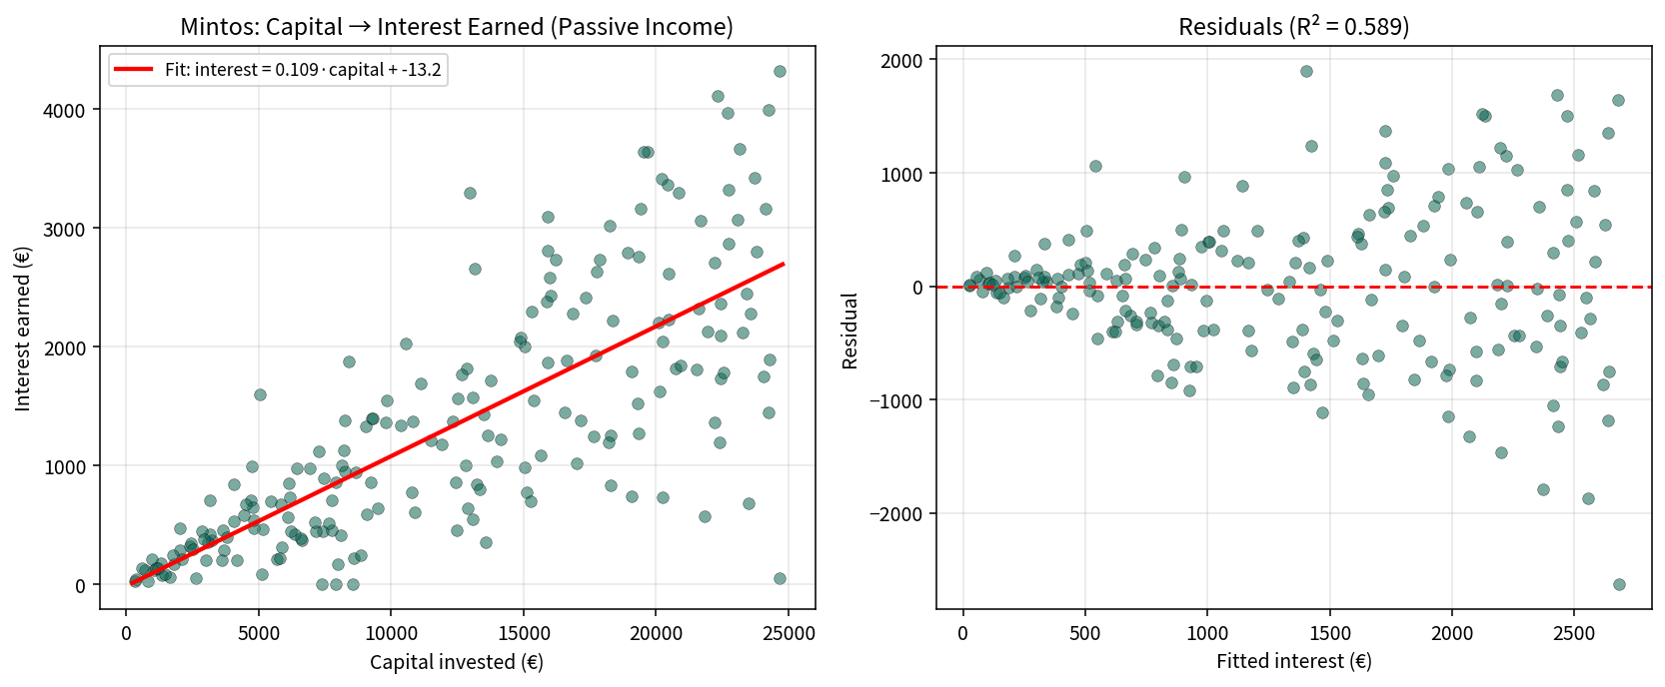
Diversification practice: ≈ 0.13 percentage points higher realized net return per extra originator in the portfolio.
Audience translations: Retail investor — “Each extra euro of capital is associated with roughly €0.11 of annual interest; the model explains about 59 % of interest variation.” Diversification — “Each additional originator is linked to about 0.13 pp higher realized return.” Non-specialist — a rising line showing that larger portfolios tend to earn more interest.

Key Takeaways
• The line of best fit minimises average squared loss; lower loss is better on the same data.
• Gradient descent moves parameters opposite the loss gradient; learning rate controls step size.
• Centering is essential when predictors (capital) are large; otherwise GD needs impractically small α.
• sklearn, closed-form and a correctly implemented GD recover the same simple-OLS coefficients.
• Always adapt charts and language to the audience (quant investors vs retail vs non-specialists).
• Synthetic teaching data inspired by publicly discussed Mintos return ranges. Not financial advice; investing involves risk of loss.

